`

**Project 5 – Self-Organized Criticality**

Kyungchan Im

Grand Canyon University

Course number: CST - 305

Professor Ricardo Citro

Due Mar 22, 2023

**Project 5 – Self-Organized Critically**

**PART 1: Mathematical Explanation**

**Description**

Fragmentation and loss of space in memory can occur due to file creations and deletions, leading to a seemingly chaotic system. As processes are swapped in and out between the disk and memory, they create natural holes or gaps in memory. When files are loaded into memory and later deleted, this process also contributes to gaps in memory. Over time, these gaps can lead to fragmentation and breakdown of the file system.

To model the chaotic behavior in memory, this project utilizes the Lorenz System, a mathematical system that describes a type of chaotic behavior. Using specific values for variables such as 𝑥, 𝑦, 𝑧, 𝑎𝑛𝑑 𝑟, the Lorenz System is modeled in Python for various values of 𝑟. By doing this, the project is able to demonstrate how a file system approaches and reaches a chaotic state.

The Lorenz System is particularly well-suited for modeling chaotic behavior in memory, as it considers the interaction between variables over time. As files are created, loaded, and deleted in memory, the system experiences fluctuations that can lead to fragmentation and loss of space.

By modeling these fluctuations using the Lorenz System, the project is able to demonstrate how a seemingly orderly system can quickly become chaotic, neutral, and in between state depends on the r value. Also, it demonstrates the importance of understanding the behavior of a file system over time. By modeling the Lorenz System, it is possible to gain insights into the underlying causes of fragmentation and loss of space in memory. This information can be used to develop more effective strategies for managing file systems, reducing the risk of system breakdown and data loss. By improving our understanding of the chaotic behavior of file systems, we can ensure that they remain reliable and efficient tools for storing and accessing data.

[ Baseline of the Lorenz Equation ]

$$\dot{x}= σ(y-x)$$

$$\dot{y}=rx-y-xz$$

$$\dot{z}=xy-bz$$

In this project, we will use the parameters 𝜎 = 10 (𝑃𝑟𝑎𝑛𝑑𝑡𝑙 𝑛𝑢𝑚𝑏𝑒𝑟), 𝑏 = 8/3 (𝑅𝑎𝑦𝑙𝑒𝑖𝑔ℎ 𝑛𝑢𝑚𝑏𝑒𝑟), 𝑎𝑛𝑑 𝑐ℎ𝑎𝑛𝑔𝑒 𝑡ℎ𝑒 𝑣𝑎𝑙𝑢𝑒𝑠 𝑓𝑜𝑟 𝑟. Furthermore, Prandtl number and Rayleigh number in this project defines the physical size.

[ Modeling the Lorenz Equation ]

When modeling file systems using the Lorenz System, the initial values for 𝑥, 𝑦, and 𝑧 were chosen to depict file size, while 𝜎 and 𝑏 were left unchanged. The variable 𝑟 was manipulated due to its effect on stability and fixed points. In the Lorenz System, a sink origin exists when 𝑟 is greater than 1. As 𝑟 increases, the number of cycles also increases, leading to a more chaotic system.

For this project, I set the x, y, and z value for $x_{0}$ = 11.8 KBs, $y_{0}$ = 4.4 KBs, $z_{0}$ = 2.4KBs. Those represents the average size of the number of image files with different file extensions. x for JPG, y for the PNG, and z for the GIF. Therefore, 𝑟 values of 8, 15, and 28 were chosen for the project to demonstrate different levels of neutral, in-between, and chaotic level.

######################################################################################

# import the packages for drawing a lorenz graph

import numpy as np

import matplotlib.pyplot as plt

######################################################################################

# initial values are assigned s = 10, b = 8/3

def lorenz(xyz, *, s=10, r=28, b=(8/3)):

"""

Parameters

----------

xyz : array-like, shape (3,)

Point of interest in three-dimensional space.

s, r, b : float

Parameters defining the Lorenz attractor.

Returns

-------

xyz_dot : array, shape (3,)

Values of the Lorenz attractor's partial derivatives at *xyz*.

"""

x, y, z = xyz

x_dot = s*(y - x)

y_dot = r*x - y - x*z

z_dot = x*y - b*z

return np.array([x_dot, y_dot, z_dot])

# setting the number of steps and increment of t

dt = 0.01

num_steps = 10000 (range of t times)

xyzs = np.empty((num_steps + 1, 3)) # Need one more for the initial values

xyzs[0] = (11.8, 4.4, 2.4) # Set initial values for x y z

[ Visualization ]

1. Neutral (Periodic) State

Depends on the r value, we can define the Lorenz of neutral (periodic) state. When r value is 8 on this model, we can see the neutral state.

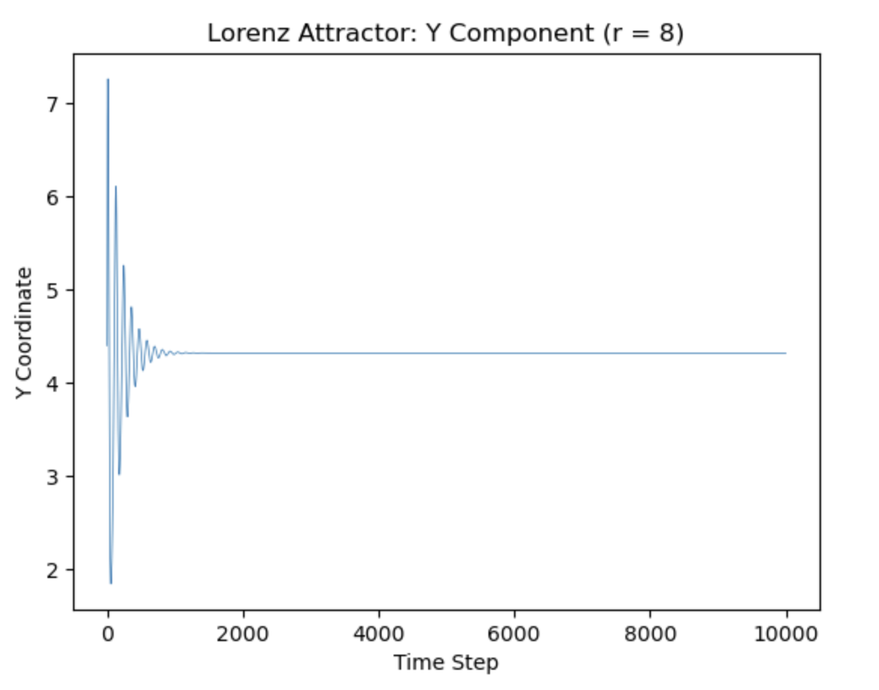

1. In-Between State

Depends on the r value, we can define the Lorenz of In-between state. When r value is 15 on this model, we can see the In-between state.

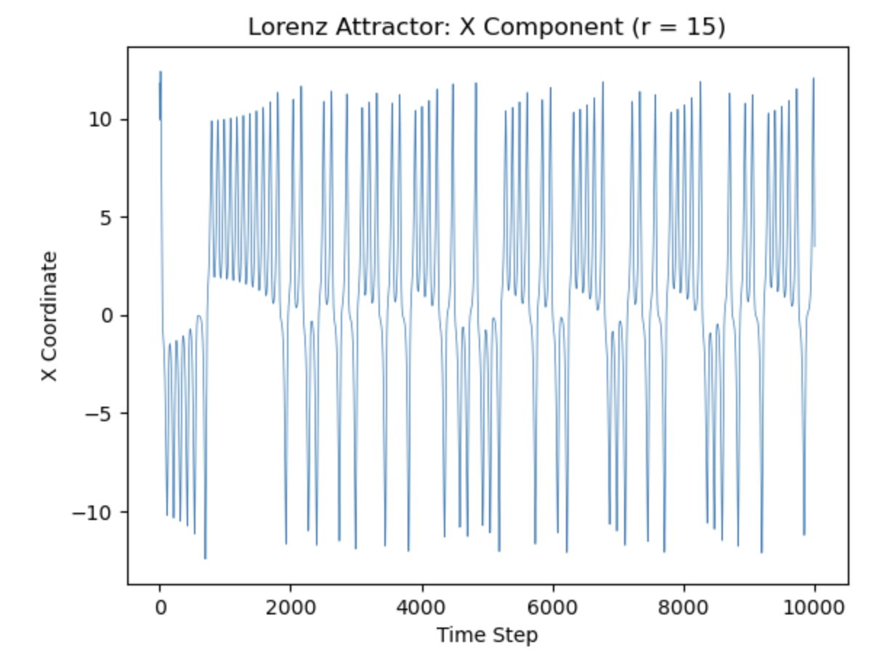

1. Chaotic State

Depends on the r value, we can define the Lorenz of Chaotic state. When r value is 28 on this model, we can see the chaotic state.

[ Explanation ]

The Lorenz system is a mathematical model that is used to simulate atmospheric convection. In this system, the initial values of x, y, and z were chosen to represent file size, with the average size of image files being used as the values. The constants 𝜎 and 𝑏 were kept unchanged since they are fixed values in the system. Therefore, only the r value was allowed to change under the given conditions. The r value represents the rate of change in the model. When r decreases, the number of cycles in the system also decreases, according to the formula. Conversely, increasing r leads to an increase in the number of cycles. This logic works because r is the only variable that determines the conditions of the cycles, as 𝜎 and 𝑏 are constant values. Given 𝑟 > 1, the Lorenz System contains a sink origin. • As 𝑟 increases, the number of cycles also increases (Tantzen & Sauter, 2015). Due to this nature, 𝑟 values were chosen as follows: 8, 15, 28. 8 was chosen because it is unchanged by the sink origin property so it represents the neutral state; thus, it will present itself uniquely. 15 was chosen because it was still relatively small but would have enough cycles to create visually remarkable results. Lastly, 28 was chosen because of its historical usage in the Lorenz System.

References

Bronson, R. & Costa, G. (2014). Schaum's outline of differential equations (4th ed.). McGraw-Hill: New York, NY. ISBN-13: 9780071822862

*Lorenz attractor#*. Lorenz attractor - Matplotlib 3.7.1 documentation. (n.d.). Retrieved March 22, 2023, from https://matplotlib.org/stable/gallery/mplot3d/lorenz_attractor.html

Tantzen J & Sauter E, (2015, July, 22). Discussion of the Lorenz Equations. Leibniz Universit¨at Hannover, from https://www.itp.uni-hannover.de/fileadmin/itp/user/ag_flohr/lectures/proseminar/ss15/Vortrag11.pdf